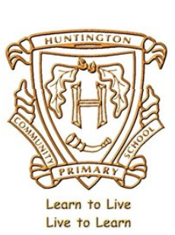

Music Curriculum: Long Term Planning
 | Autumn |  |  | Spring |  |  | Summer
Reception | Me |  | My Stories | Everyone! |  | Our World | Big Bear Funk | Reflect, Rewind and Replay
Year 1 | Hey you! |  | Rhythm in the Way we walk and Banana rap | In the Groove |  | Round and Round | Your Imagination | Reflect, Rewind and Replay
Year 2 | Hands, Feet, Heart |  | Ho Ho Ho | I Wanna Play In a Band |  | Zootime | Friendship song | Reflect, Rewind and Replay
Year 3 | Let Your Spirit Fly | Glockenspiel Stage 1 |  | Three Little Birds | The Dragon Song |  | Bringing Us Together |  | Reflect, Rewind and Replay
Year 4 | Brass instruments whole class tuition - trumpets, cornets and baritones. |  |  | Brass instruments whole class tuition - Samba drums. |  |  | Brass instruments whole class tuition - Guitar.
Year 5 | Livin’ On A Prayer | Classroom Jazz 1 |  | Make You Feel My Love | The Fresh Prince of Bel-Air |  | Dancing In The Street | Reflect, Rewind and Replay
Year 6 | Happy | Classroom Jazz 2 |  | A New Year Carol | You’ve Got A Friend |  | Music and Me |  | Reflect, Rewind and Replay
2022-2023

