The Nativity Story

adapted for children to shout out the correct word.
A long time ago, there was a lady called Mary. SUSAN
The man she was going to marry was called Joseph. JEREMY
One day, while Mary SUSAN was doing the washing up, she saw a bright light.
She had to cover her eyes because it was so bright – let the children cover their eyes.
The bright light was an angel. RAINBOW Angels are very beautiful creatures who live in Heaven and work for God.
The angel gave Mary SUSAN a message from God – he said she was going to have a baby. PUPPY
Soon Mary’s tummy started to get bigger as the baby in her tummy started to grow – can you point to your tummy?
Just a few weeks before her baby was ready to be born, the king told all the people in the country that they had to travel to the place where their family was from.
Mary and Joseph lived in Nazareth.
Mary had to travel a long way to a town called Bethlehem. BLACKPOOL
She had to walk very slowly because she had a baby in her tummy – have a go at walking slowly.
When Mary got to Bethlehem, BLACKPOOL all the hotels were full, so she had to sleep in a barn, where the animals sleep – what animals might live in a barn? Can you make their noises?
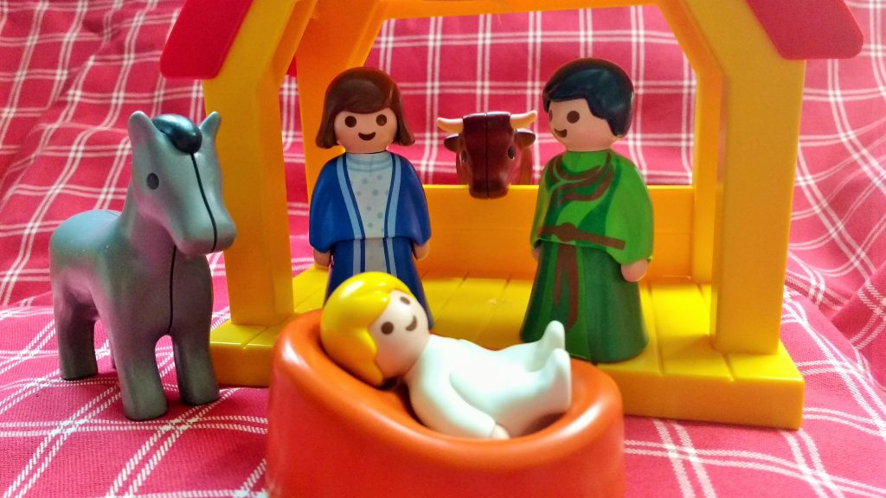
Mary, Joseph, and Baby Jesus had to sleep in a barn with the animals
That night, Mary’s baby was born. She called him ‘Jesus’. MATTHEW
Mary didn’t have a cot to put baby Jesus in so she laid him in the animal’s food bowl! In a manger.
Jesus was a special baby – he was God’s baby – and God wanted everyone to know that Jesus had been born.
Most of the people in Bethlehem BLACKPOOL were asleep – can you make a snoring sound?
But there were some shepherds in the fields, looking after their sheep – what noise does a sheep make?
God sent some angels to sing SHOUT to the shepherds and tell them all about baby Jesus.
The shepherds were so excited that they ran FLEW to the barn to see Jesus.
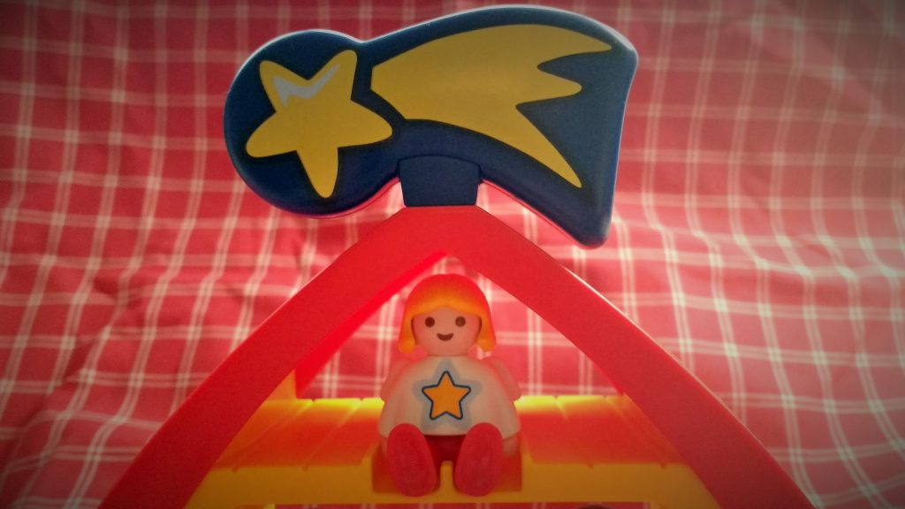
God sent some angels and a star to tell people about Jesus’ birth
God also put a giant star AEROPLANE in the sky like a big birthday candle for baby Jesus.
Some clever men (MAGI / WISE MEN) were looking at the sky and they saw the special star.
They followed the star all the way to baby Jesus.
When they saw him, they bowed down to tell Jesus that they thought he was special – can the children bow?

The traditional nativity story is getting squeezed out of Christmas, because the shops can make a lot more money off the back of Santa. But real nativity story is just as magical and it’s part of our heritage. Children love the story, and I hope this simple version helps you to share the nativity story with your little one.
